**Project report**

**on**

**Realization of Analog Circuits using FPAA and**

**Familiarization using Analog Discovery Kit**

*by*

**MOUMITA MAJI**

*Under the supervision of*

**Prof. Rahul Bhattacharya**

(Department of Electronics Engineering, IIT ISM DHANBAD)



**DEPARTMENT OF ELECTRONICS ENGINEERING**

**INDIAN INSTITUTE OF TECHNOLOGY**

**(INDIAN SCHOOL OF MINES)**

**DHANBAD – 82600**

**CANDIDATE’S DECLARATION**

I hereby declare that

1. The work contained in this report is original and has been done by us under the guidance of our supervisor *Prof. Rahul Bhattacharya,* Assistant professor, Department of Electronics, IIT ISM Dhanbad.
2. The work has not been submitted to any other Institute for any degree or diploma.
3. I have followed all the guidelines provided by the Institute in preparing the report.
4. I have conformed to the norms and guideline given in the Ethical Code of Conduct of the Institute.
5. Wherever I have used materials (data, theoretical analysis, figures and texts) from other sources, I have given due credit to them by citing them in the project report and giving their details in the reference. Further I have taken permission from the copyright owners of the sources, wherever necessary.

Signature of the Student

**DEPARTMENT OF ELECTRONICS ENGINEERING**

**INDIAN INSTITUTE OF TECHNOLOGY**

**(INDIAN SCHOOL OF MINES)**

**DHANBAD – 826004**



**CERTIFICATE**

**____________________________________________________________**

This is to certify that the project report entitled “Realization of Analog Circuits Using FPAA Kit and Familiarization with Analog Discovery Kit” submitted by **Moumita Maji**, **B.Tech**  student, is a record of bona fide project work carried out by her during the **Summer Research Internship at Indian Institute of Technology (Indian School of Mines), Dhanbad**, under my supervision.

To the best of my knowledge, the work presented in this report is original and has not been submitted to any other university or institute for the award of any degree or diploma.

(Project Supervisor)

Examined and Approved

**Head of Department (ECE)**

**ACKNOWLEDGEMENT**

This research work is one of the significant achievements in my life and is made possible because of the unending encouragement and motivation given by so many in every part of my life. It is immense pleasure to have this opportunity to express my gratitude and regards to them.

Firstly, I would like to express my gratitude and sincere thanks to **Prof**. **Rahul Bhattacharya**, my supervisor, Department of Electronics Engineering at IIT ISM Dhanbad for his esteemed supervision and guidance during the tenure of my project work.

By

Moumita Maji

**CONTENTS**

Title Page i

Candidate’s Declaration ii

Certificate iii

Acknowledgement iv

Contents

Abstract

Chapter 1 Overview

1.1 Introduction

1.2 Literature Review

Chapter 2 Tools and Technology Used

2.1 Analog Discovery Kit

2.2 Field Programmable Analog Array (FPAA) Kit

Chapter 3 Experimental Study and Implementation

*3.1 Experimental Study of Analog Discovery Kit-Based Circuits*

3.1.1 Inverting Amplifier

3.1.2 Non-Inverting Amplifier

3.1.3 Integrator (Low Pass Filter)

3.1.4 Frequency and Phase Response

3.1.5 Diode Characteristics

3.1.6 PNP Transistor Characteristics

3.1.7 Sallen-Key Filter

3.1.8 Biquadratic Filter

*3.2 Experimental Study of FPAA-Based Circuits*

3.2.1 Full-Wave Rectifier

3.2.2 Voltage-Controlled Oscillator (VCO)

3.2.3 Phase Shift Detector

3.2.4 Schmitt Trigger

3.2.5 Square Wave Oscillator

3.2.6 Gilbert Multiplier

Chapter 4 Conclusion and References

4.1 Conclusion

4.2 References

**Abstract**

With the rapid evolution of electronic technology, there is an increased demand for compact, efficient, and adaptable analog systems. Traditional analog circuits, while necessary for signal processing, confront limitations in terms of flexibility, design complexity, and prototype costs. To solve these restrictions, our research focuses on the design, implementation, and analysis of analog circuits using two powerful and adaptable platforms: the Analog Discovery Kit and the Field Programmable Analog Array (FPAA).

The objective of this project is: first, to implement and analyse fundamental analog circuits—including amplifiers, filters, and semiconductor device characteristics—using the Analog Discovery Kit and WaveForms software; and second, to explore reconfigurable analog design through the implementation of advanced circuits such as the Schmitt Trigger, Voltage-Controlled Oscillator (VCO), Phase Shift Detector, and Square Wave Generator using the FPAA (AN231E04) and AnadigmDesigner2 software.

project emphasizes hands-on circuit realization, dynamic setup, and waveform analysis. The FPAA-based designs demonstrate the benefits of programmable analog hardware for rapid prototyping, parameter tuning, and circuit reconfiguration without requiring physical alterations. This approach allows for more efficient testing, less hardware complexity, and improved adaptability to design.

The overall goal is to gain a better knowledge of analog circuit behaviour on modern reconfigurable platforms, bridging the theoretical and practical gaps. The findings show that both technologies simplify analog circuit testing while also improving flexibility and learning outcomes, setting the framework for more complex system designs in the future.

Supervisor

**Chapter 1**

**INTRODUCTION**

**1.1 OVERVIEW**

With the rapid advancement of electronic technology, there is an increasing demand for efficient, compact, and reconfigurable circuit solutions, particularly in the field of analog electronics. Analog circuits are essential in numerous applications including communication systems, signal processing, instrumentation, and control systems. However, traditional methods of analog circuit realization often involve rigid hardware setups, complex wiring, and time-consuming adjustments, which can limit the flexibility and speed of design iterations.

To address these challenges, modern tools such as the Analog Discovery Kit and Field Programmable Analog Arrays (FPAA) have emerged as powerful platforms for circuit design, testing, and analysis. These platforms provide hands-on experience while offering the flexibility to implement and modify a wide range of analog circuits with minimal physical effort.

The Analog Discovery Kit, developed by Digilent, is a compact and portable device that combines multiple laboratory instruments into a single unit. It allows for the construction, simulation, and real-time observation of analog and digital circuits using software tools such as WaveForms. With features like oscilloscopes, waveform generators, network analyzers, and power supplies, the Analog Discovery Kit makes circuit analysis accessible and cost-effective.

The Field Programmable Analog Array (FPAA), introduces the concept of reconfigurable analog hardware. Similar to how Field ProgrammableGate Arrays (FPGAs)revolutionized digital design, FPAA technology enables users to implement, test, and modify analog circuits dynamically through software-driven configurations. Using tools like, complex analog systems including filters, oscillators, rectifiers, and signal conditioning circuits can be realized on the FPAA chip without the need for permanent hardware changes.

This project focuses on the realization and analysis of analog circuits using both the Analog Discovery Kit and the FPAA Kit. The first part of the work involves the design and testing of fundamental analog circuits such as amplifiers, filters, and device characteristics using the Analog Discovery Kit. The second part involves the implementation of more advanced circuits including waveform generators, phase shift detectors, and Schmitt Triggers using the FPAA Kit.

The objective is to gain practical experience in analog circuit design, understand circuit behaviour through observation and simulation in educational and research environments.

.

**1.2 LITERATURE REVIEW**

* The use of field programmable analog arrays (FPAA) has introduced a flexible, reconfigurable approach to analog circuit design, enabling real-time updates of analog functions through software-controlled configurable analog blocks (CABs). FPAA technology reduces circuit complexity, accelerates design time, and allows for on-field updates, making it suitable for rapid prototyping, signal processing, and adaptive applications. The AN221E04 FPAA device, along with AnadigmDesigner2 software, facilitates the design and testing of analog systems such as filters, amplifiers, and waveform generators efficiently and with minimal hardware constraints [1].
* A study on the design and investigation of a square-wave generator using FPAA demonstrated the advantages of programmable control over both frequency and duty cycle. Implemented using the AN220D04 evaluation board from Anadigm, the system employed switched capacitor techniques and modular IP blocks for dynamic waveform generation. The results highlighted how FPAA allows designers to synthesize and modify complex circuits through software without requiring physical changes, promoting flexibility and faster development cycles [2].
* The design of a CMOS Gilbert multiplier using FPAA technology has been explored to enable nonlinear analog signal processing on a reconfigurable hardware platform. By implementing the multiplier within FPAA architecture, the design reduced complexity and improved adaptability compared to fixed CMOS implementations. This work highlights the potential of FPAA in applications such as modulation, frequency mixing, and analog computation, where real-time reconfiguration is beneficial [3].
* The implementation of a Schmitt trigger circuit using FPAA has showcased the utility of reconfigurable analog hardware for building waveform shaping circuits. The study utilized the flexibility of FPAA to design a comparator with hysteresis, demonstrating how dynamic adjustment of threshold levels and switching behavior can be achieved without physical circuit changes. This approach enhances both design flexibility and testing efficiency in analog systems [4].

**Chapter 2**

**THEORETICAL STUDY**

**2.1 Tools and Technology Used**

The circuits in this project were designed, implemented, and tested using two main tools: the Analog Discovery Kit and the Field Programmable Analog Array (FPAA) Kit. Both tools provided a flexible and cost-effective approach for hands-on experimentation and circuit analysis.

**2.1.1 Analog Discovery Kit**

The Analog Discovery Kit, developed by Digilent, is a versatile, portable electronic instrumentation device that provides multiple laboratory-grade instruments in a compact, USB-powered unit. It is designed specifically for students, hobbyists, and engineers to build and test circuits without the need for bulky, expensive equipment typically found in traditional laboratories.

The kit is driven by the WaveForms software, which offers an intuitive graphical user interface for accessing and controlling the internal instruments. The main instruments available include:

* Two-channel oscilloscope (±25 MHz bandwidth)
* Two-channel arbitrary waveform generator
* Power supplies (+5 V, -5 V, variable supply)
* Network analyzer for Bode plot generation
* Logic analyzer and pattern generator

These tools allow users to perform a wide range of experiments including signal visualization, frequency response analysis, component characterization, and time-domain measurements.

One of the key advantages of the Analog Discovery Kit is its ability to combine multiple instruments into a single, portable device, enabling circuit testing anywhere without the limitations of physical lab setups. This enhances accessibility and allows for rapid prototyping and debugging of analog and digital systems.

In this project, the Analog Discovery Kit was used to implement fundamental analog circuits such as operational amplifier configurations (inverting and non-inverting amplifiers), filters (integrator, Sallen-Key, Biquadratic), and to study the characteristics of diodes and transistors. The oscilloscope and network analyzer features were particularly useful for observing waveforms and analyzing frequency and phase response of these circuits.

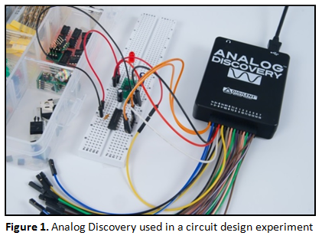

**2.1.2 Field Programmable Analog Array (FPAA) Kit**

Field Programmable Analog Arrays (FPAAs) are reconfigurable devices that enable the design and implementation of analog circuits entirely through software without requiring physical changes to hardware. They function similarly to Field Programmable Gate Arrays (FPGAs) but are used for analog rather than digital circuit design. This flexibility makes FPAAs ideal for rapid prototyping, research, and educational purposes.

The FPAA device used in this project is the Anadigm AN221E04, which employs switched capacitor technology. In this technology, an equivalent resistance is created by switching the inputs of a capacitor at high frequencies. The effective resistance depends on both the capacitor value and the switching frequency, offering adjustable performance controlled by software.

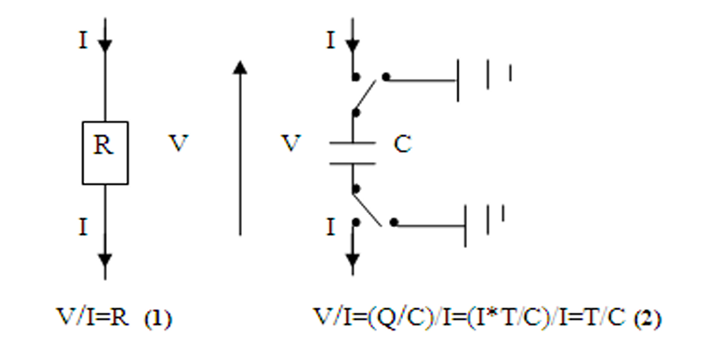

Fig 2.2 Switched capacitor Technology

The core building block of the FPAA is the Configurable Analog Block (CAB), which contains an operational amplifier and a network of switched capacitors. The AN221E04 consists of a 2x2 matrix of these CABs, surrounded by programmable interconnects and input/output cells. The device includes four configurable I/O cells and two dedicated output cells, with configuration data stored in on-chip SRAM memory.

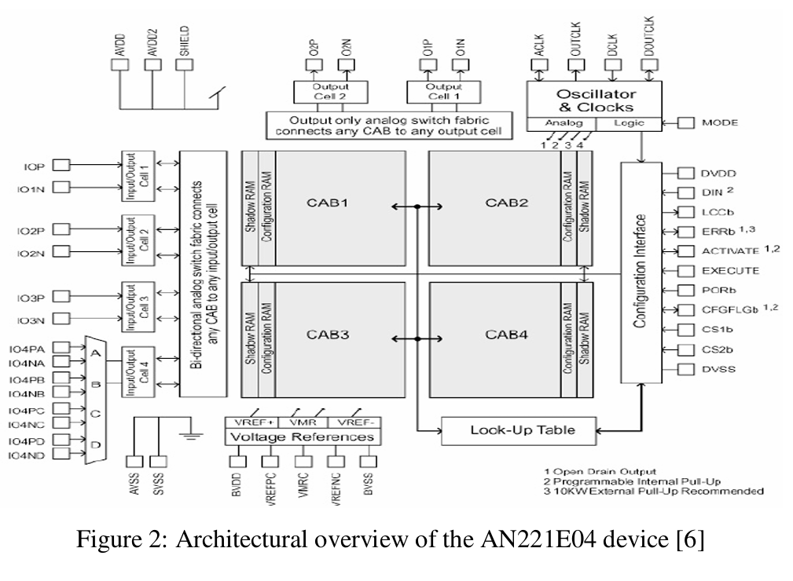

Fig 2.3. Architectural overview of the AN221E04 device

Circuit design and simulation are performed using AnadigmDesigner2 software, which provides a library of pre-configured analog modules such as amplifiers, filters, and waveform generators. These Configurable Analog Modules (CAMs) are mapped onto the CABs to create complete circuits. The design is then downloaded to the FPAA evaluation board via a serial interface, allowing the circuit to be executed in real-time.

The key advantage of FPAA technology is its ability to allow instant design changes, parameter adjustments, and reprogramming without physical rewiring. In this project, various analog circuits such as waveform generators, Schmitt triggers, and phase detectors were implemented using FPAA, demonstrating the platform’s flexibility and ease of use for analog circuit experimentation.

**Chapter 3**

**EXPERIMENTAL STUDY AND METHODOLOGY**

**3.1 Experimental Study of Analog Discovery Kit-Based Circuits**

The Analog Discovery Kit was used to design, simulate, and analyze various fundamental analog circuits. This section provides the theoretical background of each circuit along with its key working principles.

**3.1.1 Inverting Amplifier**

An inverting amplifier is an operational amplifier (op-amp) configuration where the input signal is applied through a resistor to the inverting terminal of the op-amp, while the non-inverting terminal is grounded. Negative feedback is provided by connecting the output back to the inverting terminal through another resistor.

The voltage gain of the circuit is given by:

Av = – Rf / Rin

where Rf is the feedback resistor and Rin​ is the input resistor. The negative sign indicates a 180-degree phase shift between input and output.

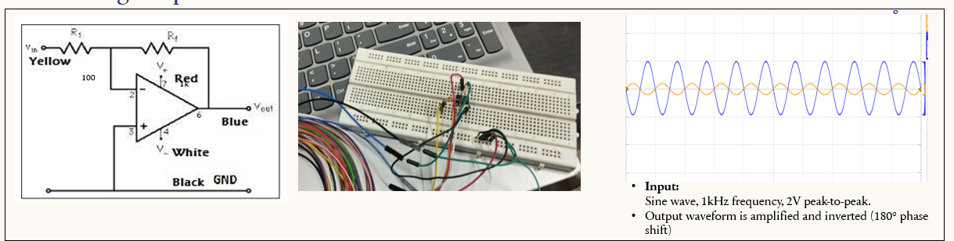

Fig 3.1.1 Circuit Diagram, Breadboard implementation and output waveform of Inverting Amplifier

**3.1.2 Non-Inverting Amplifier**

In a non-inverting amplifier, the input signal is applied to the non-inverting terminal of the op-amp, while the inverting terminal is connected to ground through a resistor divider network. This configuration provides positive voltage gain without phase inversion.

The gain of the amplifier is given by: Av = 1 + (Rf / Rin).

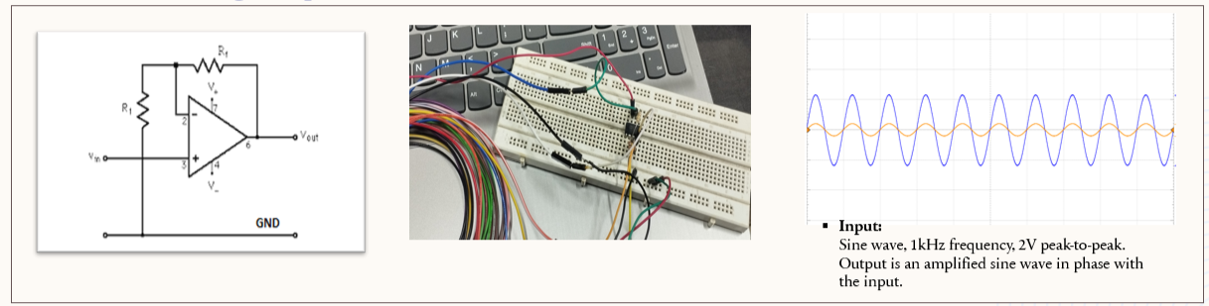

Fig 3.1.2 Circuit Diagram, Breadboard implementation and output waveform of Non Inverting Amplifier

**3.1.3 Integrator (Low Pass Filter)**

An integrator circuit is realized by connecting a capacitor in the feedback path of an inverting op-amp. The output voltage is proportional to the integral of the input voltage, effectively acting as a low-pass filter by attenuating high-frequency signals.

The relationship is given by: Vout(t) = – (1/RC) × ∫ Vin(t) dt.

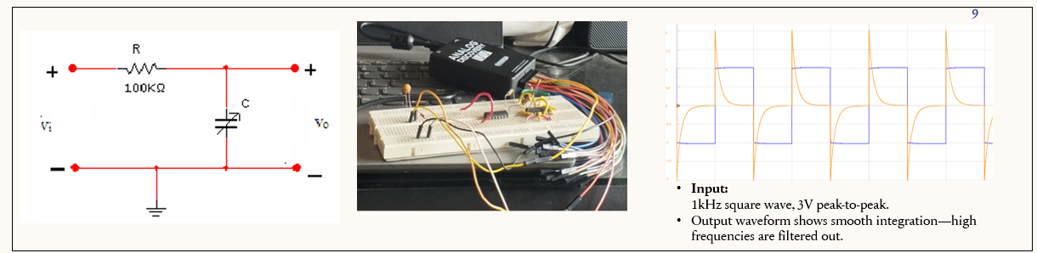

Fig 3.1.3 Circuit Diagram, Breadboard implementation and output waveform of Integrator (Low Pass Filter)

**3.1.4 Frequency and Phase Response (Bode Plot)**

The frequency response of a circuit describes how the gain and phase of the output vary with input frequency. Using the network analyzer tool in the Analog Discovery Kit, Bode plots were obtained for circuits such as filters and amplifiers to measure cutoff frequency and phase shift across frequencies.Bode plots help in determining the behavior of the circuit in the frequency domain, including stability and bandwidth.

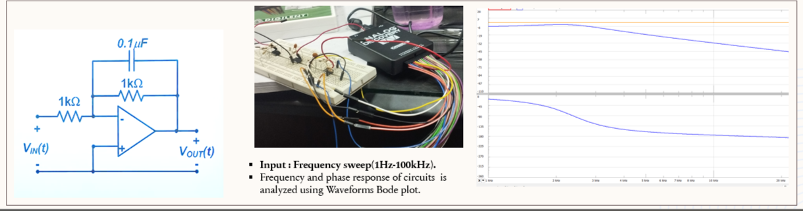

Fig 3.1.4 Circuit Diagram, Breadboard implementation and output waveform of Frequency and Phase Response (Bode Plot)

**3.1.5 Diode Characteristics**

The diode characteristic experiment involves studying the relationship between the current and voltage of a PN junction diode. When forward biased, the diode allows current flow beyond the threshold voltage, while in reverse bias, current is minimal until breakdown occurs.

The characteristic curve obtained shows the nonlinear behavior of the diode.

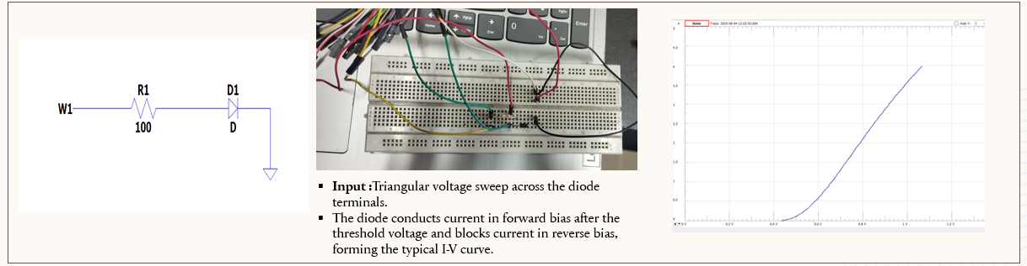

Fig 3.1.5 Circuit Diagram, Breadboard implementation and output waveform of Diode Characteristics

**3.1.6 PNP Transistor Characteristics**

The PNP transistor characteristics were studied by measuring the collector current versus collector-emitter voltage for different base currents. The resulting family of curves identifies the transistor's active, cutoff, and saturation regions.

Understanding these characteristics is essential for designing amplifiers and switching circuits.

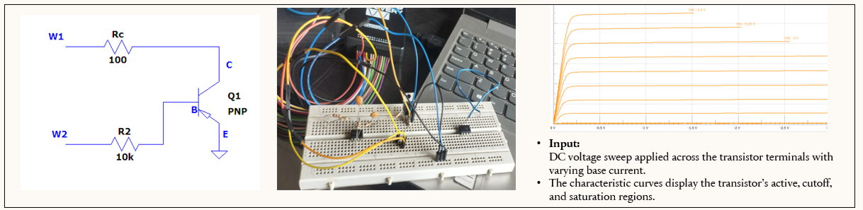

Fig 3.1.6 Circuit Diagram, Breadboard implementation and output waveform of PNP Transistor Characteristics

**3.1.7 Sallen-Key Filter**

The Sallen-Key filter is a popular second-order active filter configuration commonly used in signal processing and control applications. It consists of an operational amplifier along with resistors and capacitors arranged to achieve either low-pass, high-pass, or band-pass filtering.

In this experiment, the Sallen-Key low-pass filter was designed and implemented using the Analog Discovery Kit. The key advantage of this filter is that it provides a sharper roll-off in the frequency response compared to first-order filters. This means that it can better separate signals based on frequency, making it useful for noise reduction, audio applications, and

communication systems.

The cutoff frequency (fc) of the Sallen-Key low-pass filter is determined by the resistor and capacitor values and is given by the formula:

fc = 1 / [2π × √(R1 × R2 × C1 × C2)]

By selecting appropriate values of resistors and capacitors, the desired cutoff frequency can be set.

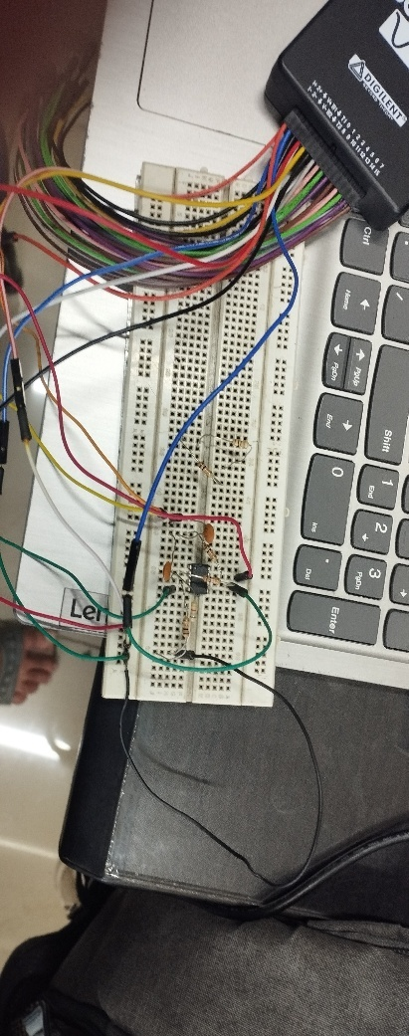The frequency response of the circuit was analyzed using the network analyzer tool in the Analog Discovery Kit. The results showed that the filter effectively attenuates signals above the designed cutoff frequency while allowing low-frequency components to pass with minimal distortion.

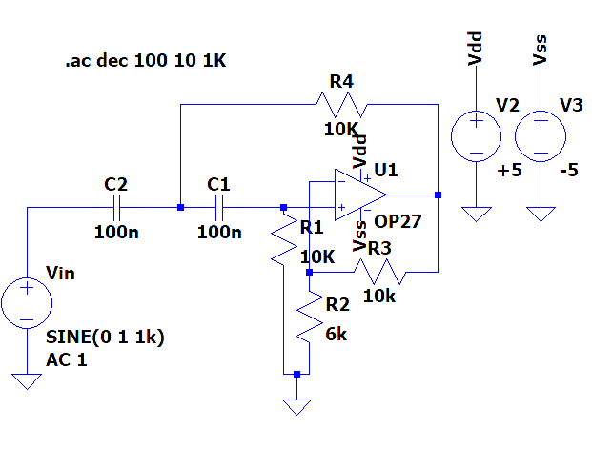

Fig 3.1.7aCircuit diagram of Fig 3.1.7b Breadboard Implementation of Sallen key filter

Sallen key filter

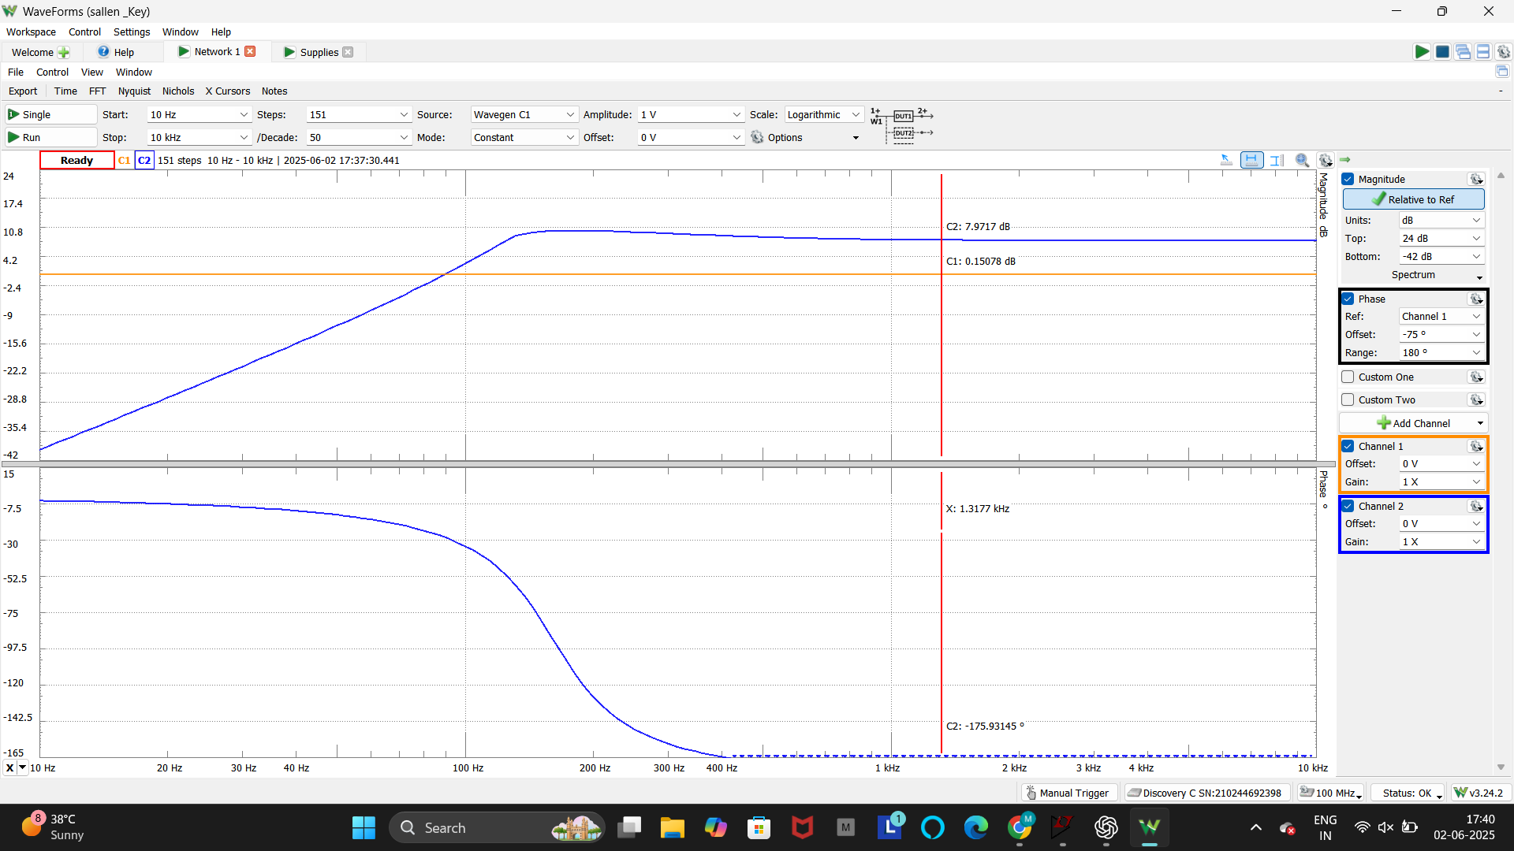

Fig 3.1.7c Output waveform of Sallen Key filter

**3.1.8 Biquadratic Filter**

The biquadratic filter, commonly referred to as the biquad filter, is a second-order active filter that offers greater design flexibility and sharper frequency selectivity compared to basic RC filters. The term "biquadratic" refers to the fact that its transfer function includes a squared term in the denominator, which allows for precise control over the filter's frequency response.

The biquad filter can be configured as a low-pass, high-pass, band-pass, notch, or all-pass filter depending on the arrangement of the components and feedback paths. It is widely used in applications such as audio processing, communication systems, and digital signal processing where accurate frequency control is required.

In this project, the biquad filter was implemented using operational amplifiers along with carefully selected resistor and capacitor values to achieve the desired filtering characteristics. The key parameters that define the performance of the biquad filter include:

* Center frequency (f0): The frequency around which the filter operates.
* Bandwidth (BW): The range of frequencies that the filter affects.
* Quality factor (Q): A measure of how sharp or selective the filter is.

The theoretical analysis and practical implementation using the Analog Discovery Kit showed that the biquad filter offers superior frequency selectivity, sharper cutoff slopes, and better stability in comparison to simple first-order circuits. The filter's response was verified using frequency analysis tools, and the expected sharp roll-off behavior was observed.

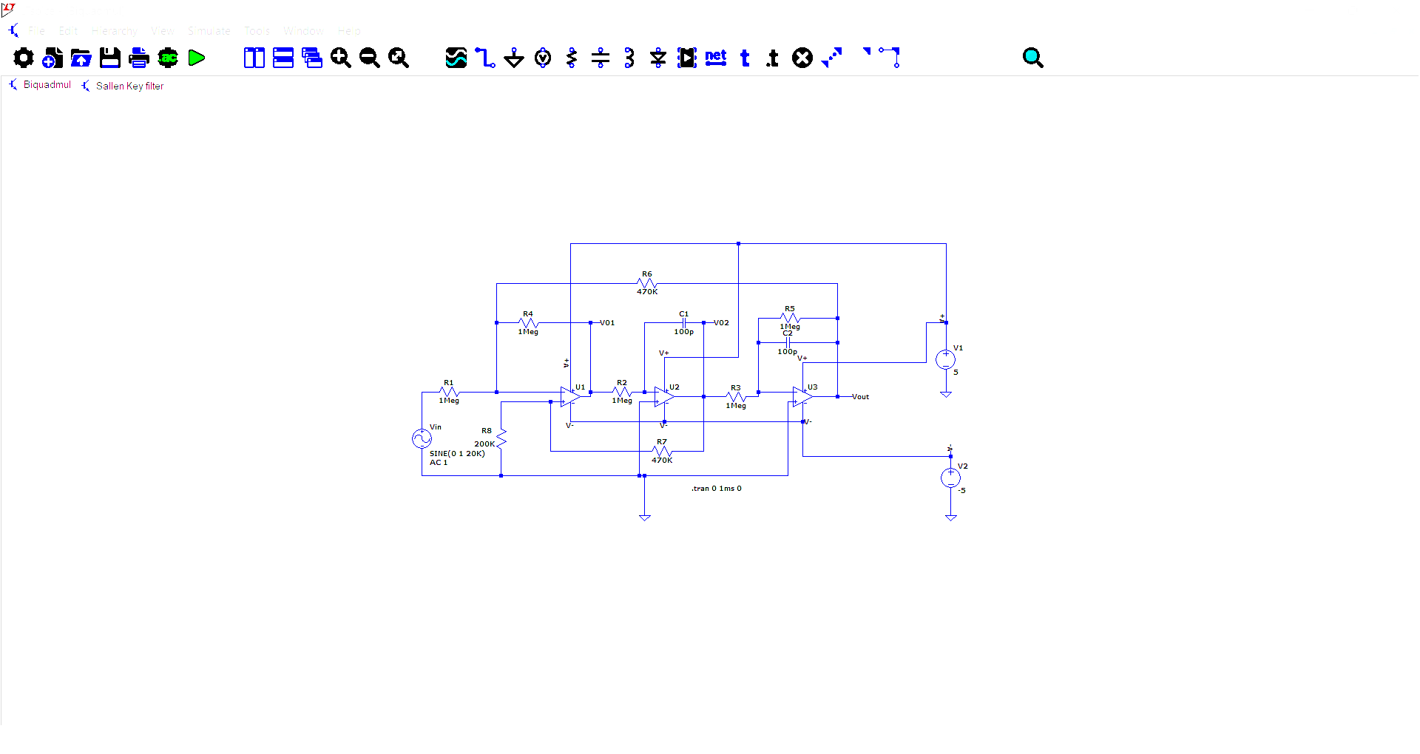

Fig 3.8.1a Circuit diagram of Biquad Filter

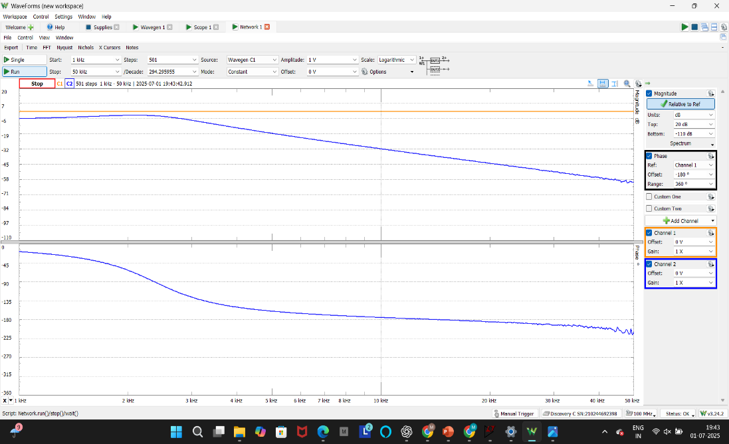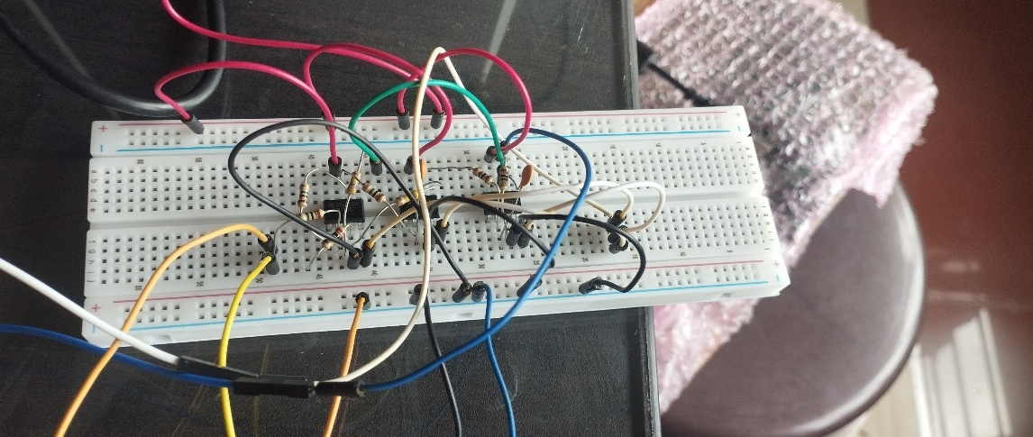

Fig 3.1.8.b Breadboard Implementation of Biquad Fig 3.1.9.c Output Waveform of Biquad Filter

Filter

**3.2 Experimental Study of FPAA Based Circuits**

The Field Programmable Analog Array (FPAA) platform was used to design, implement, and analyze various analog circuits with real-time configurability. The circuits were designed using AnadigmDesigner2 software and implemented on the AN231E04 FPAA chip. This section presents a detailed theoretical study and experimental observation of each circuit in the order followed in the project presentation.

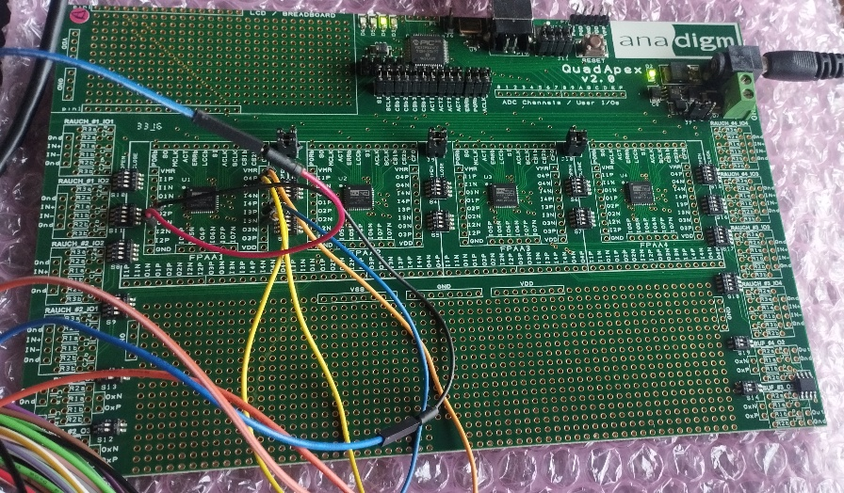

Fig 3.2 FPAA Board

**3.2.1 Full-Wave Rectifier**

A full-wave rectifier converts an alternating current (AC) input signal into a pulsating direct current (DC) output by inverting the negative half-cycles of the input waveform. Unlike half-wave rectifiers, which eliminate half of the input waveform, full-wave rectifiers utilize both halves, resulting in improved efficiency and reduced ripple.

In the FPAA-based implementation, operational amplifiers and absolute value blocks were used to achieve full-wave rectification without relying on traditional diodes. The switched capacitor technology enabled precise control of the rectifier behavior, ensuring minimal signal distortion and adaptability to various input frequencies.

The rectifier was tested by applying a sinusoidal input, and the output waveform displayed a clear unidirectional signal corresponding to the absolute value of the input. This result was confirmed using the oscilloscope in analog discovery (scope), validating the theoretical working of the circuit.

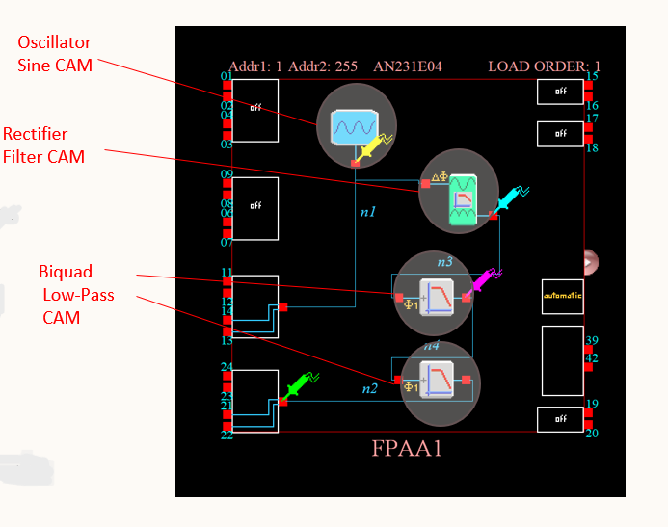

Fig 3.2.1a Full-Wave Rectifier Implementation Using Anadigm Designer with CAM Configurations

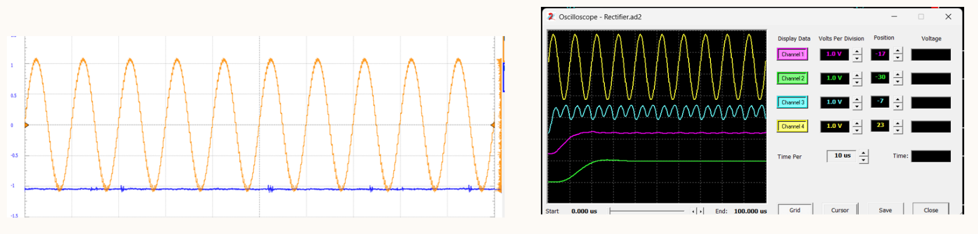

Fig 3.2.1b Full-Wave Rectifier output analog discovery Fig 3.2.1c Full wave rectifier output in scope

**3.2.2 Voltage-Controlled Oscillator (VCO)**

A Voltage-Controlled Oscillator (VCO) is a circuit that generates a periodic waveform, typically a sine or square wave, with a frequency that is directly proportional to an applied control voltage. VCOs are fundamental in applications such as frequency modulation, clock generation, and communication systems

In this FPAA implementation, the VCO was realized by integrating operational amplifiers, capacitive elements, and a control voltage input. The frequency of oscillation increased or decreased linearly in response to changes in the control voltage. This dynamic behavior was easily configured and modified using AnadigmDesigner2 software. 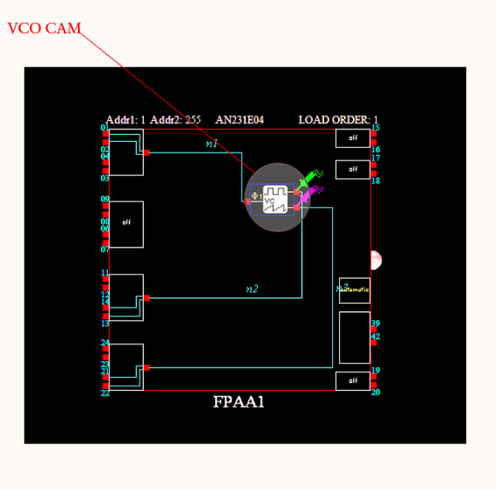

Fig 3.2.2 a VCO Implementation Using Anadigm Designer with CAM Configurations

The circuit's output was tested by varying the control voltage and observing the resulting waveforms on an oscilloscope. The experiment successfully demonstrated the core functionality of the VCO, confirming the theoretical predictions.

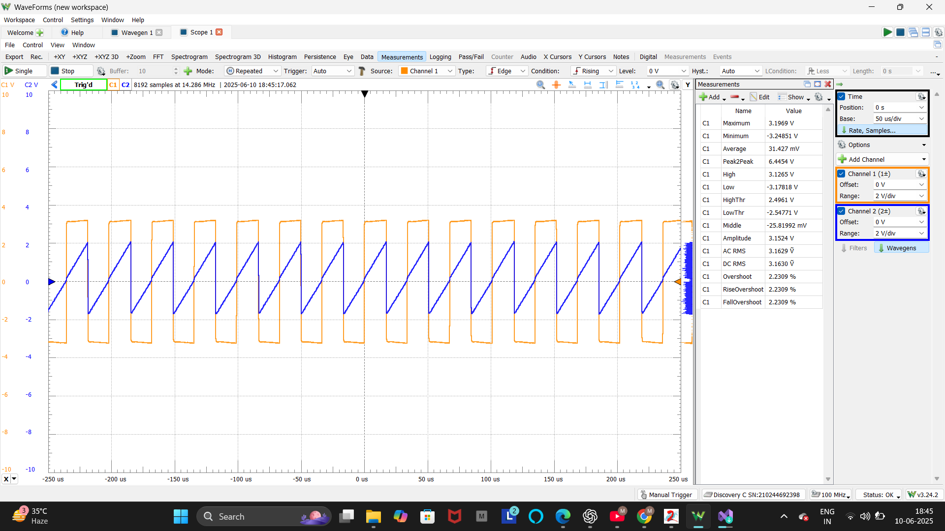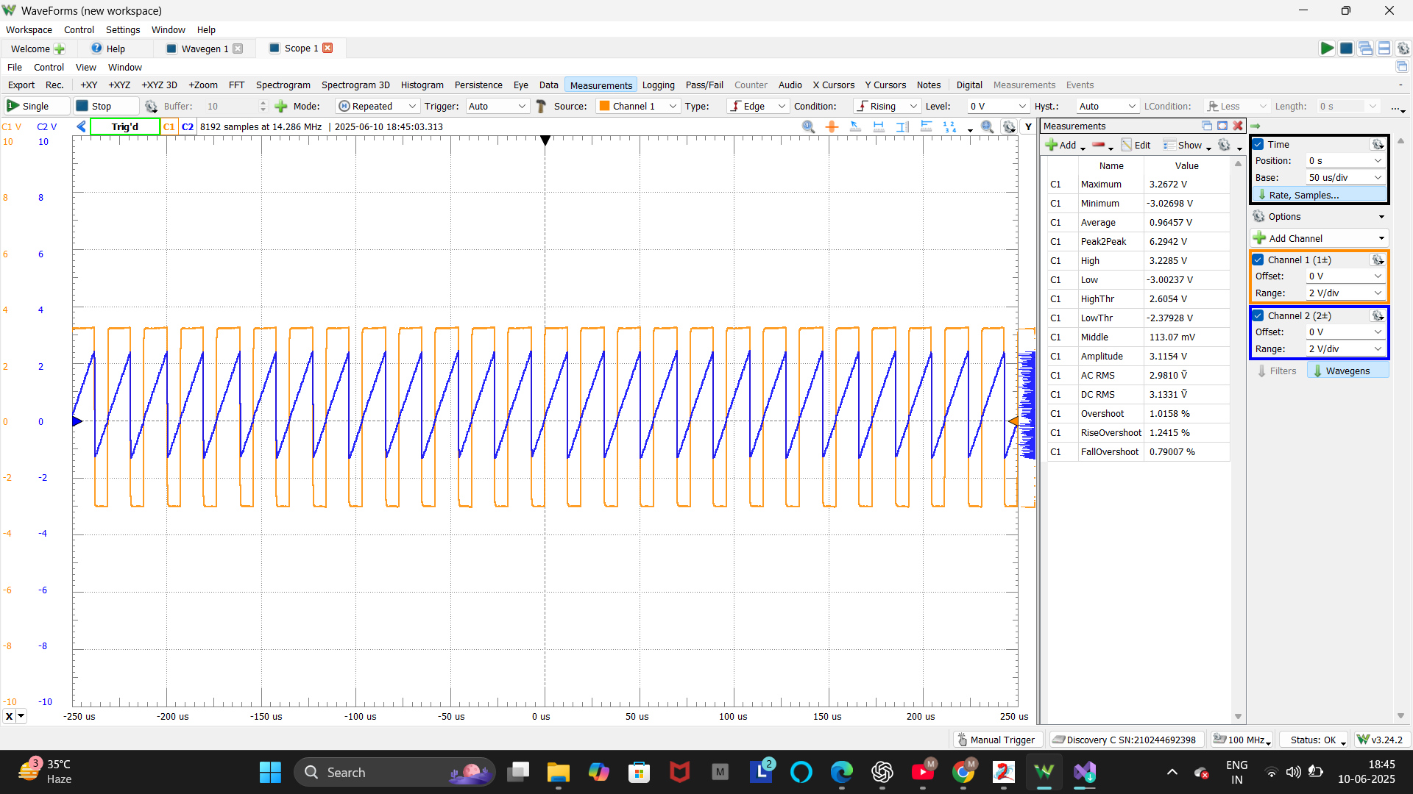

Fig3.2.2b Output waveform of VCO at analog discovery scope with changing voltages

**3.2.3 Phase Shift Detector**

A Phase Shift Detector is an essential circuit used to measure the phase difference between two periodic signals. This type of circuit is critical in applications such as synchronization, motor control, and phase-locked loops.

In the FPAA-based design, the Phase Shift Detector used comparators to convert analog sine wave inputs into digital square waveforms. These outputs were then fed into a digital comparator to detect phase differences by measuring the timing between rising edges. The use of FPAA allowed easy adjustment of thresholds and comparison logic.

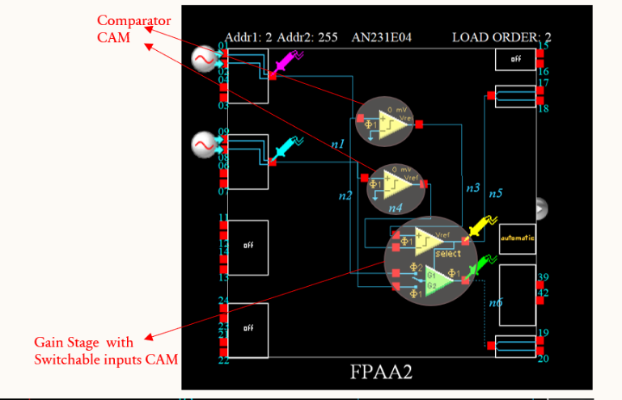

Fig 3.2.3a Phase shift detector Implementation Using Anadigm Designer with CAM Configurations

The experimental validation involved feeding two sinusoidal signals into the circuit and observing the phase difference output on the oscilloscope. The circuit reliably detected and displayed phase differences, demonstrating accurate performance.

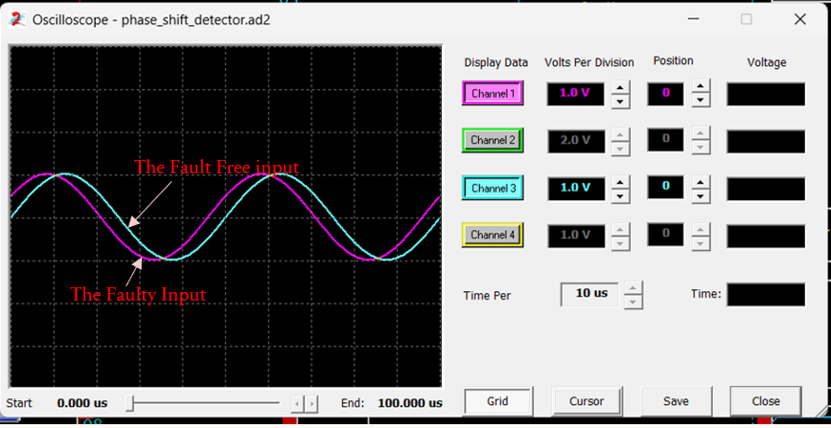

Fig 3.2.3b the fault-free and the faulty outputs simulation

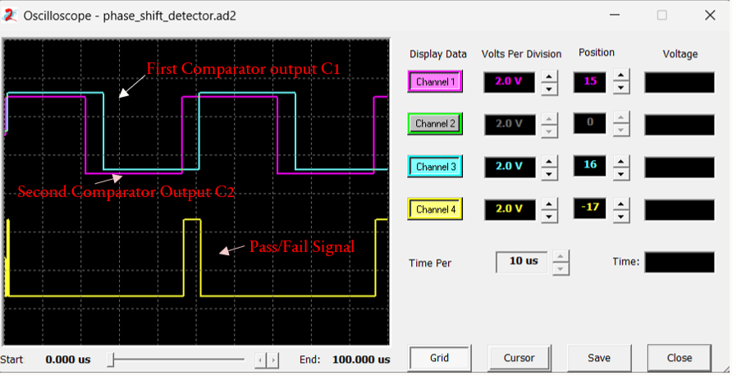

Fig 3.2.3c the fault-free, the faulty

and the Pass/Fail outputs simulation result

**3.2.4 Schmitt Trigger**

A Schmitt Trigger is a comparator circuit with hysteresis, characterized by having two distinct threshold voltages: an upper threshold for switching high and a lower threshold for switching low. This feature allows the Schmitt Trigger to effectively filter out noise from input signals, providing clean digital transitions.

In this FPAA implementation, the Schmitt Trigger was constructed using operational amplifiers configured with positive feedback to introduce hysteresis. The ability to dynamically set threshold voltages using AnadigmDesigner2 made the circuit highly adaptable to different

signal conditions. 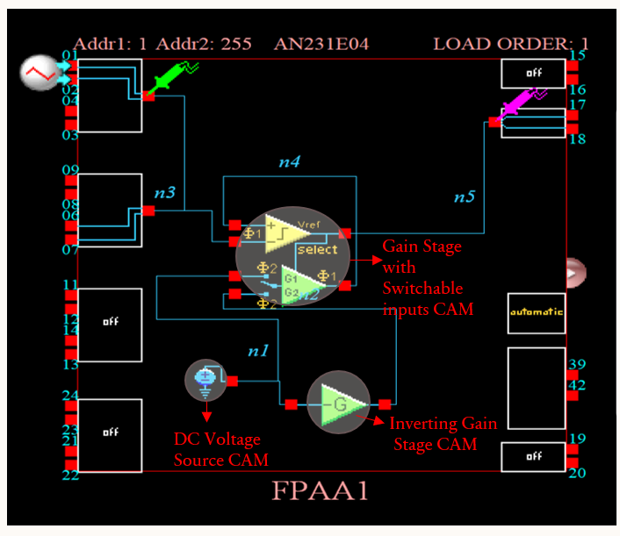

The circuit's functionality was tested by applying a noisy sine wave input.

Fig 3.2.4a Schmitt Trigger Circuit Implementation Using Anadigm Designer with CAM Configurations

The oscilloscope displayed a clean square wave output, validating the noise immunity and switching precision of the Schmitt Trigger.

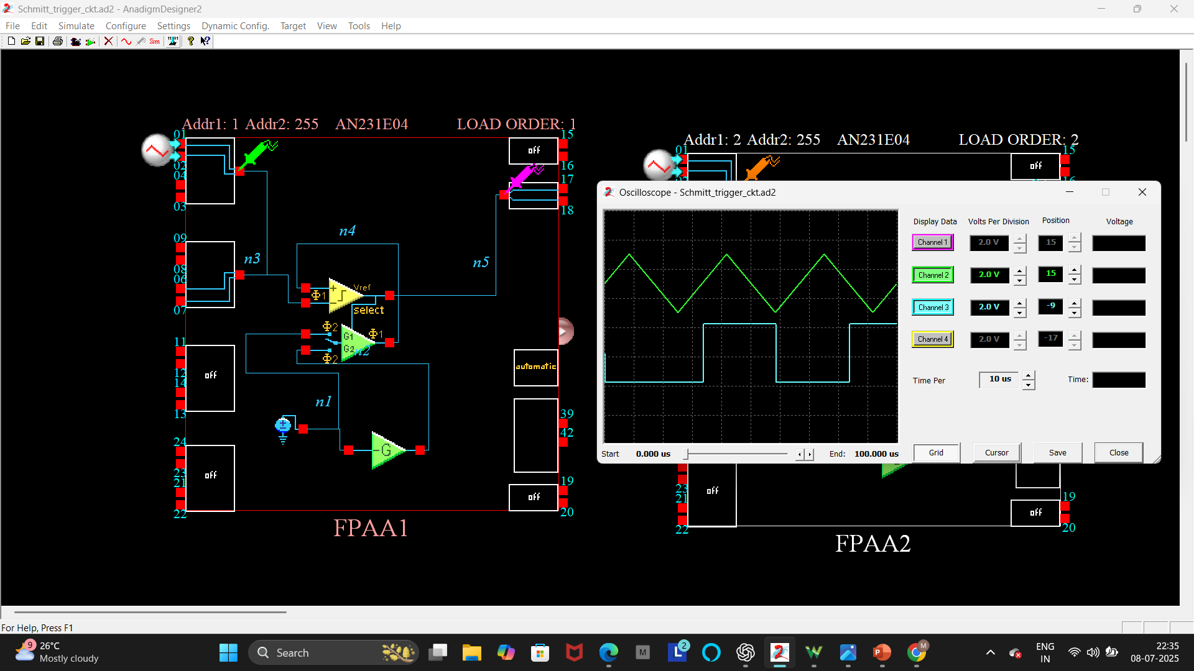

Fig 3.2.4b Schmitt trigger circuit output in scope

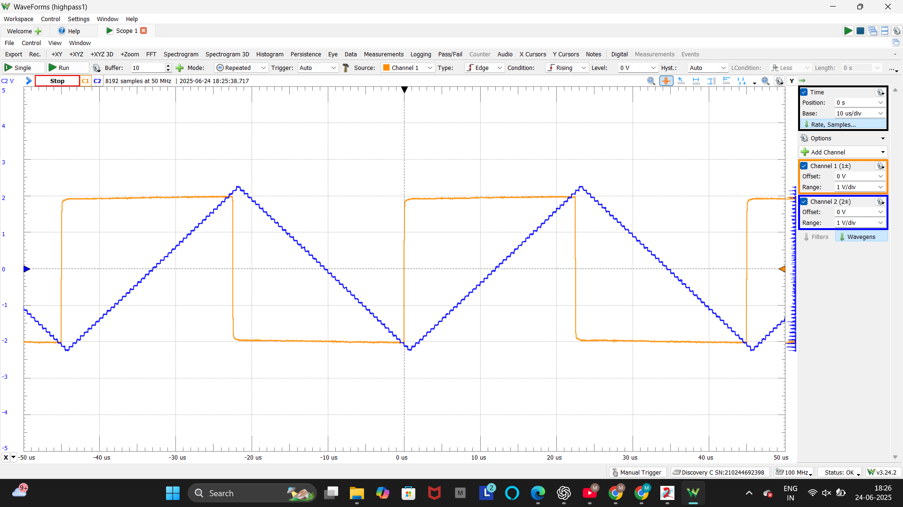

Fig 3.2.4c Schmitt Trigger output in analog discovery

**3.2.5 Square Wave Oscillator**

A Square Wave Oscillator is a circuit that generates a continuous square waveform, which is widely used in digital electronics for timing, clock generation, and switching applications. The square wave consists of alternating high and low voltage levels with a defined frequency and duty cycle.

Using FPAA, the oscillator was designed with switched capacitor blocks and comparator modules. The frequency and duty cycle were easily adjustable within the software, allowing for

real-time modifications without physical changes to the hardware.

The square wave output was visualized using the oscilloscope, confirming the successful generation of stable waveforms at various frequencies. The experiment demonstrated the ease and precision of waveform generation using FPAA technology.

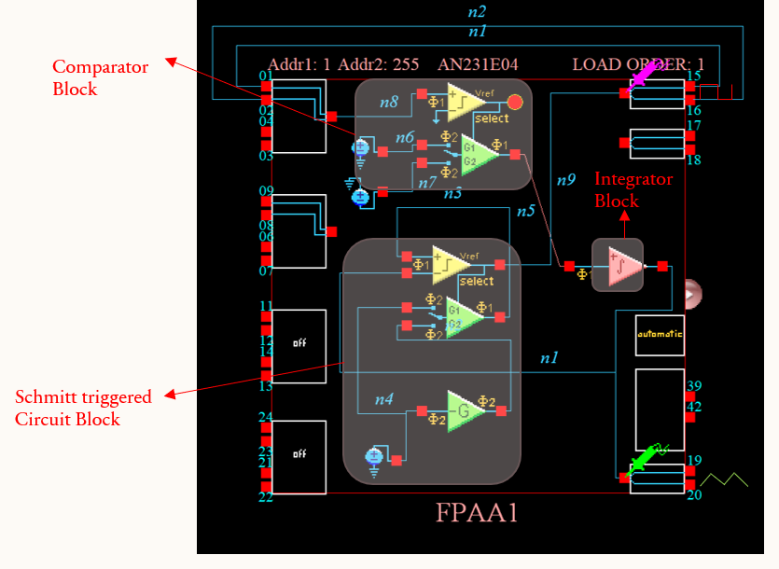

Fig 3.2.5a Schmitt Trigger Circuit Implementation Using Anadigm Designer with CAM Configurations

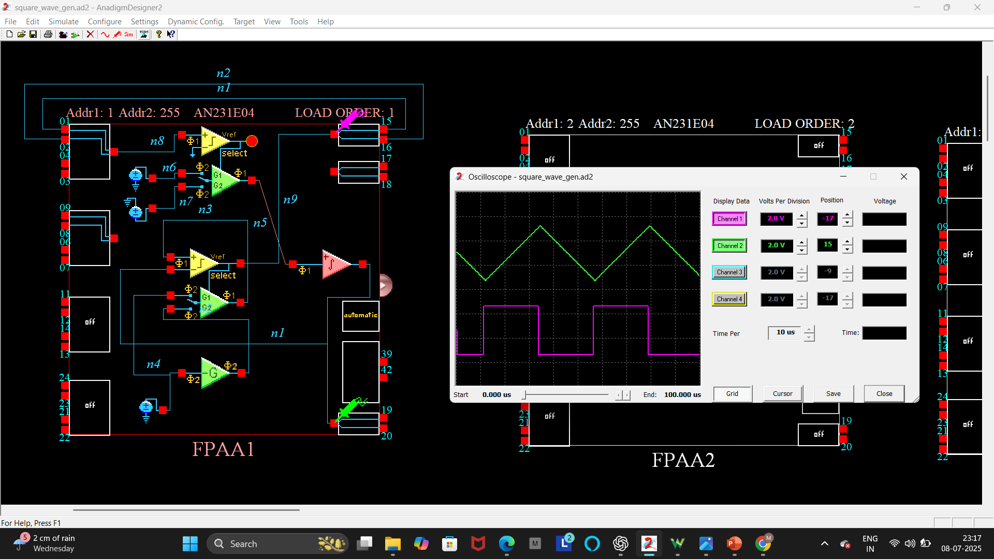

Fig 3.2.5b Square wave oscillator circuit output in scope

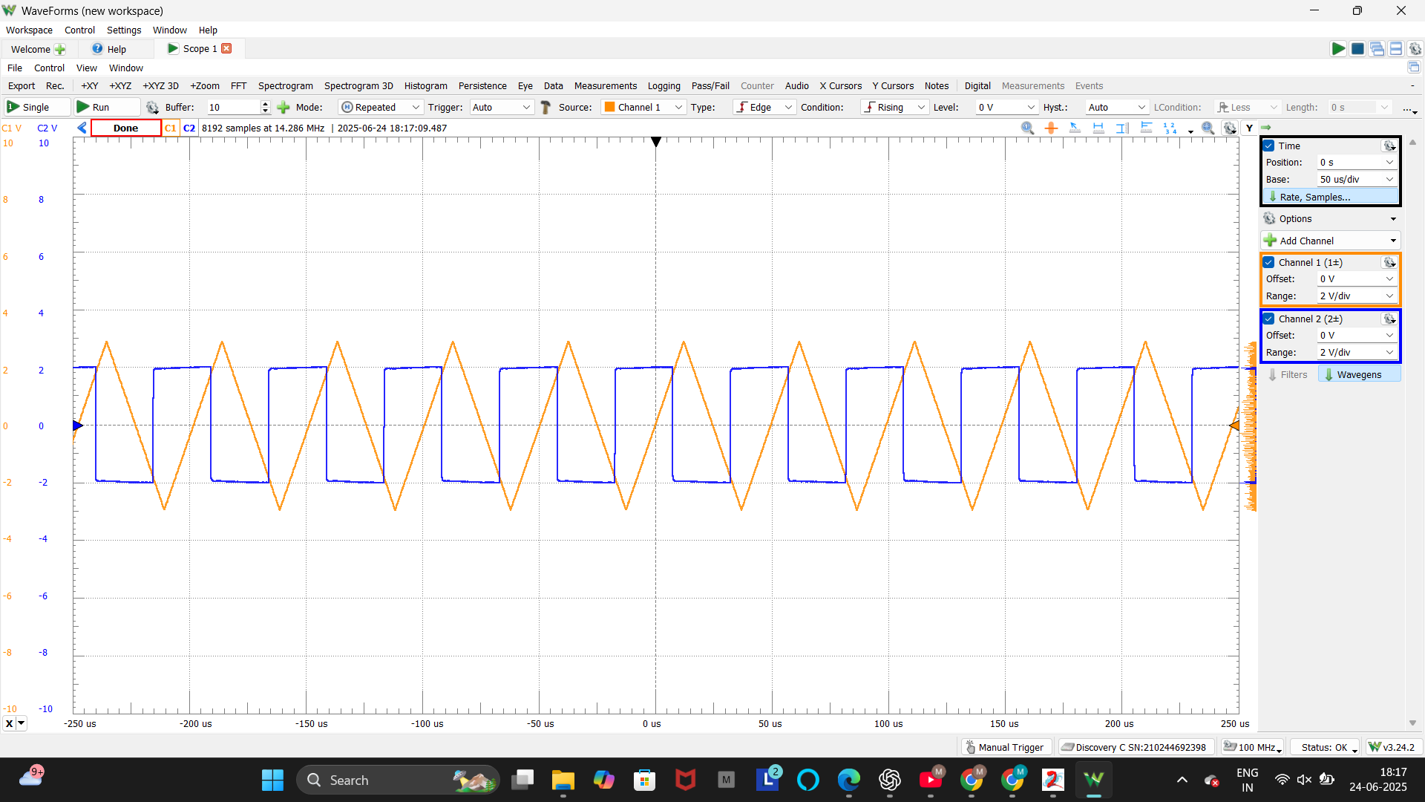

Fig 3.2.5c Square wave oscillator output in analog discovery

**3.2.6 Gilbert Multiplier**

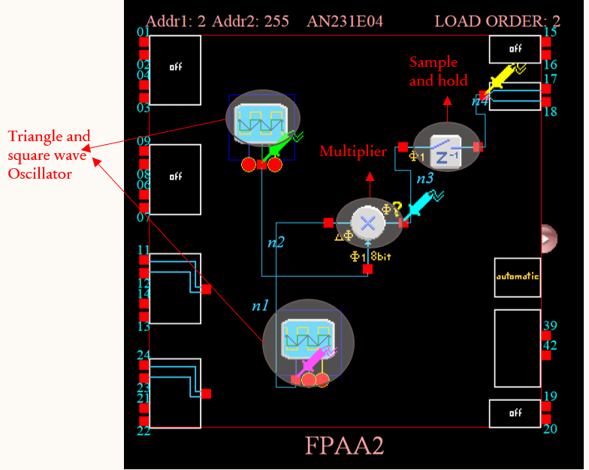The Gilbert Multiplier is a classic analog circuit used for multiplying two signals, typically employed in communication systems for modulation, mixing, and frequency translation. It is known for its linearity and balanced operation.

Fig 3.2.6a Gilbert Multiplier Implementation Using Anadigm Designer with CAM Configurations

In the FPAA-based implementation, the Gilbert Multiplier was realized using linear amplifiers and differential pair configurations available in AnadigmDesigner2. The use of switched capacitor technology allowed the circuit to be implemented without discrete transistors or resistors.

The circuit was tested by applying two sinusoidal input signals. The resulting output waveform, which contained the product of the two inputs, was observed using the oscilloscope. The experimental results confirmed the correct operation of the multiplier and highlighted the FPAA's capability to handle nonlinear analog functions effectively.

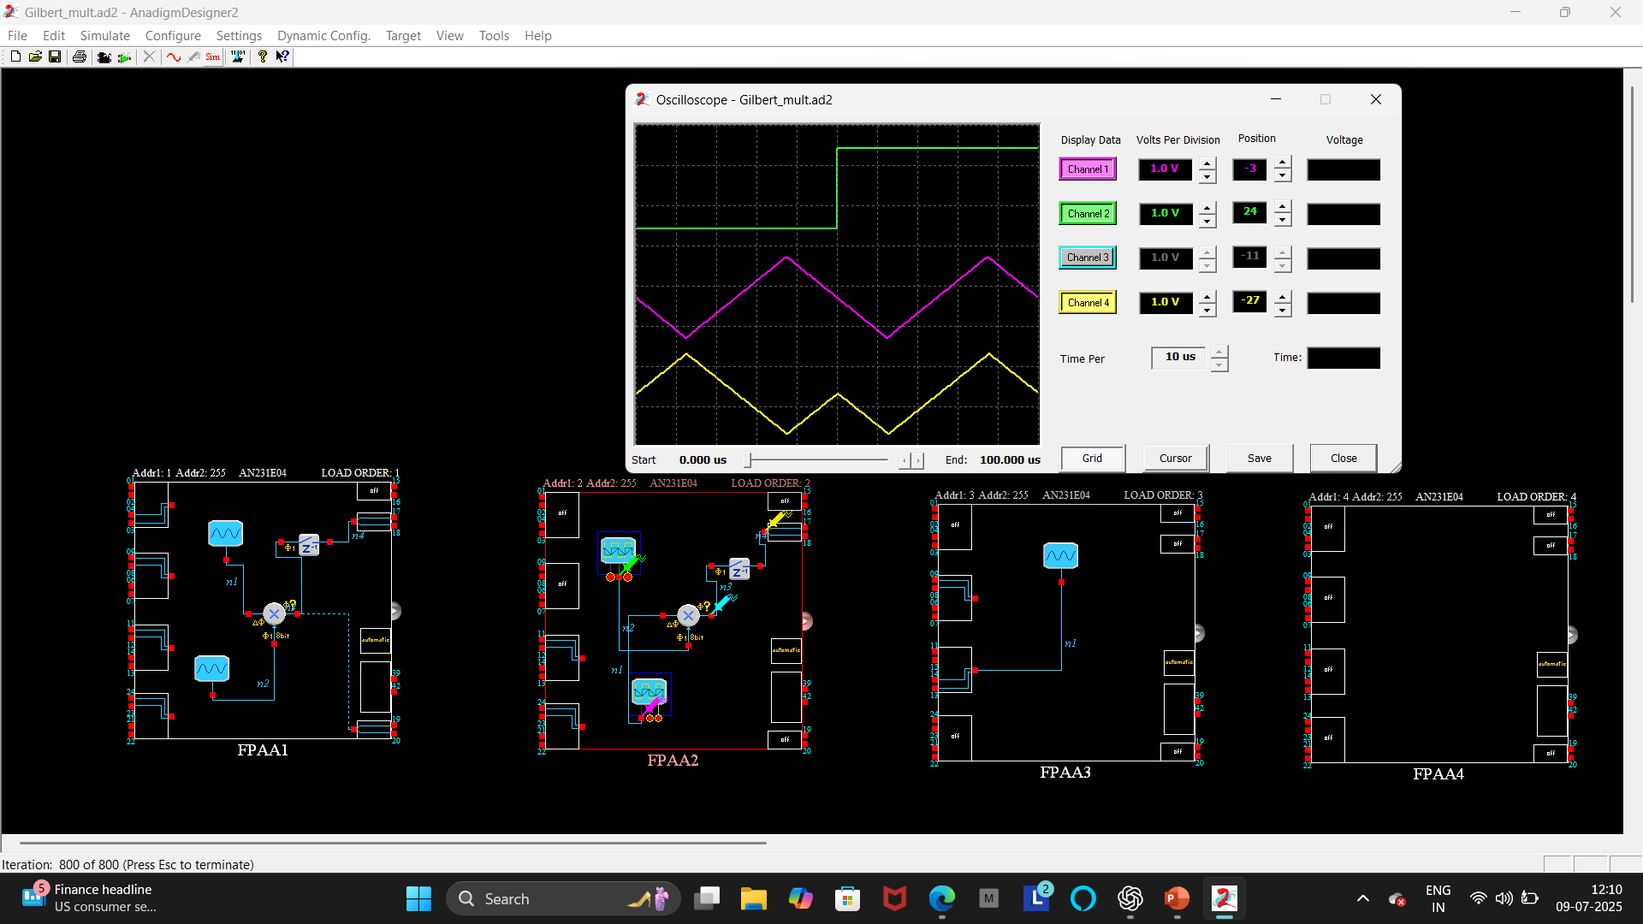

Fig 3.2.6b Gilbert Multiplier circuit output in scope

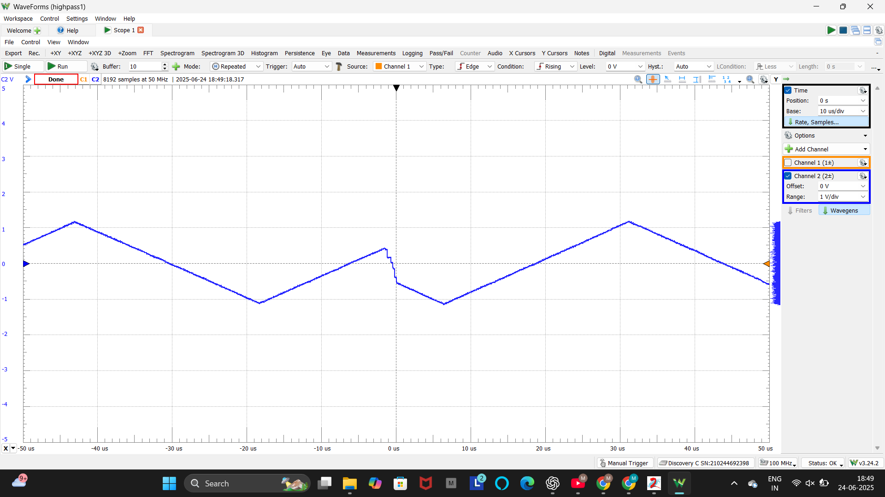

Fig 3.2.6c Gilbert Multiplier output in analog discovery

**Chapter 4**

**Conclusion**

The objective of this internship project was to design, implement, and analyze various analog circuits using both the Analog Discovery Kit and the Field Programmable Analog Array (FPAA) platform. The project provided hands-on experience in circuit design, simulation, and real-time testing of both fundamental and advanced analog systems, bridging the gap between theoretical learning and practical application.

The implementation of a wide range of circuits—including amplifiers, filters, rectifiers, waveform generators, phase detection circuits, and signal multipliers—allowed for a comprehensive exploration of core analog design principles. The use of the FPAA, specifically the AN231E04 device with AnadigmDesigner2 software, highlighted the flexibility and efficiency of reconfigurable analog hardware. The ability to dynamically modify circuit parameters without physical component changes not only reduced development time but also showcased the cost-effectiveness of software-driven analog system design.

Each circuit was carefully tested and validated using the Analog Discovery Kit, where waveform outputs were observed, analyzed, and compared with theoretical expectations. The practical implementation reinforced key concepts such as signal amplification, filtering, rectification, waveform shaping, and signal multiplication. Additionally, the experiments provided deeper insight into the behavior of semiconductor devices like diodes and transistors, as well as the impact of phase differences in analog signal processing.

Through this work, the significant advantages of FPAA technology—such as dynamic reconfigurability, high adaptability, and support for rapid prototyping—were clearly demonstrated. The exposure to switched-capacitor technology, configuration of analog modules, and hands-on waveform analysis contributed to a well-rounded learning experience, enhancing both circuit design skills and analytical thinking.

Moreover, the internship fostered an appreciation for the importance of analog design in modern electronic systems, including communication devices, sensor interfaces, and signal processing units. The knowledge and skills gained through this project not only align with academic goals but also provide a strong foundation for future research, industry applications, and advanced studies in the field of electronics and embedded systems.

**References**

[1] M. Karmani, C. Khedhiri, B. Hamdi, “Analog Integrated Circuit Design and Testing Using the Field Programmable Analog Array Technology,” *International Journal of Advances in Engineering & Technology (IJAET)*, Vol. 1, Issue 4, pp. 1–9, Sept. 2011.

[2] A. Tomar, M. Kaushik, P. Singh, R. Saxena, “Design and Investigation of a Square-Wave Generator Using Field Programmable Analog Array (FPAA),” *Proceedings of the International Conference on Electronics, Signals, and Telecommunication (ICEST)*, pp. 96–99, 2004.

[3] H. A. Sonawane, A. K. Singh, S. S. Waghmare, “CMOS Gilbert Multiplier for Analog Signal Processing and Its FPAA Based Implementation,” *International Journal of Computer Applications*, Vol. 95, No. 6, pp. 20–24, 2014.

[4] A. P. Singh, S. S. Bhagwat, “Design and Implementation of Schmitt Trigger Circuit Using FPAA,” *International Journal of Engineering Research & Technology (IJERT)*, Vol. 3, Issue 5, May 2014.

[5] II-I AES Lab Manual